**Marketing Analytics Business Case**

Leonel Ale

Contents

Business problem 4

**Key Performance Indicators (KPIs)** 4

Objectives 5

Data structure 6

Dimensions tables (DIM) 6

• Customers 6

• Products 6

• Calendar 6

Fact Tables 7

• Journey 7

• Reviews 7

• Engagement 7

• Review with sentiment 7

Executive summary 8

Key Insights 9

**Decreased** **Conversion** **Rates** 9

**Reduced Customer Engagement** 10

**Customer Feedback Analysis** 11

Goals and Actions 12

Increase conversion rates 12

Goal 12

Insight 12

Action 12

Enhance Customer Engagement 12

Goal 12

Insight 12

Action 12

Increase conversion rates 13

Goal 13

Insight 13

Action 13

Dashboards Power BI 14

Overview 14

Conversion rate 14

Social media 15

Customer reviews 15

SQL 16

FACT tables 16

Reviews 16

Engagements 16

Customer journey 17

Dimension tables 18

Customers 18

Products 18

# Business problem

* ShopEasy, an online retail business, is facing reduced customer engagement and conversion rates despite launching several new online marketing campaigns. They are reaching out to you to help conduct a detailed analysis and identify areas for improvement in their marketing strategies.
* **Key Points:**
  + **Reduced Customer Engagement:** The number of customer interactions and engagement with the site and marketing content has declined.
  + **Decreased Conversion Rates:** Fewer site visitors are converting into paying customers.
  + **High Marketing Expenses:** Significant investments in marketing campaigns are not yielding expected returns.
  + **Need for Customer Feedback Analysis:** Understanding customer opinions about products and services is crucial for improving engagement and conversions.

## **Key Performance Indicators (KPIs)**

* **Conversion Rate:** Percentage of website visitors who make a purchase.
* **Customer Engagement Rate:** Level of interaction with marketing content (clicks, likes, comments).
* **Average Order Value (AOV):** Average amount spent by a customer per transaction.
* **Customer Feedback Score:** Average rating from customer reviews.

## Objectives

* **Increase Conversion Rates:**
  + **Goal:** Identify factors impacting the conversion rate and provide recommendations to improve it.
  + **Insight:** Highlight key stages where visitors drop off and suggest improvements to optimize the conversion funnel.
* **Enhance Customer Engagement:**
  + **Goal:** Determine which types of content drive the highest engagement.
  + **Insight:** Analyze interaction levels with different types of marketing content to inform better content strategies.
* **Improve Customer Feedback Scores:**
  + **Goal:** Understand common themes in customer reviews and provide actionable insights.
  + **Insight:** Identify recurring positive and negative feedback to guide product and service improvements.

# Data structure

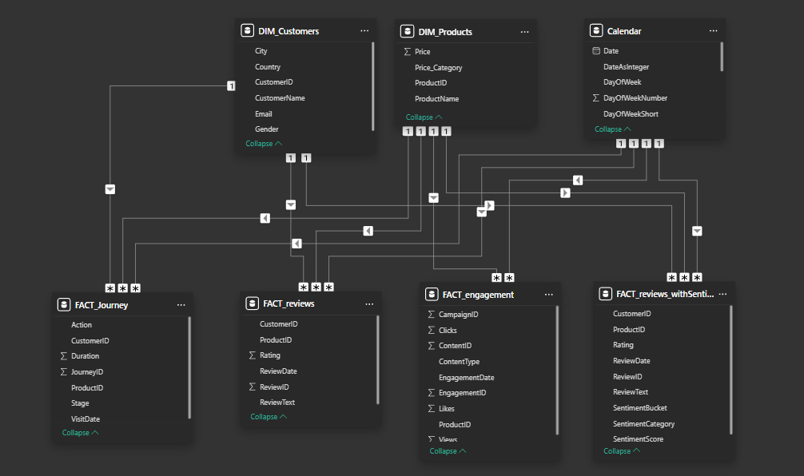

## Dimensions tables (DIM)

### Customers

Contains information about the customers, including unique identifiers, names, contact details, and demographic data used to analyze customer behavior and preferences

### Products

Stores details about the products, such as product IDs, names, categories, prices, and other attributes essential for inventory and sales analysis.

### Calendar

Provides a comprehensive date structure, including years, months, weeks, and holidays, to support time-based analyses and reporting. This data wasn’t included in the data set, so I added it with DAX formulas.

## Fact Tables

### Journey

Tracks customer journeys in digital marketing, including actions taken, customer IDs, journey IDs, product references, stages of the journey, visit dates, and duration of interactions. This data enables the analysis of user behavior, campaign performance, and customer flow through various marketing stages.

### Reviews

Holds customer feedback, including review IDs, product or service references, and ratings, providing insights into customer satisfaction and product performance.

### Engagement

Tracks customer interactions across various channels, such as website visits, social media activity, and email campaigns, helping measure customer engagement levels.

### Review with sentiment

Extends the reviews data with sentiment analysis, including sentiment scores and classifications (e.g., positive, neutral, negative), offering deeper insights into customer opinions and trends.

# Executive summary

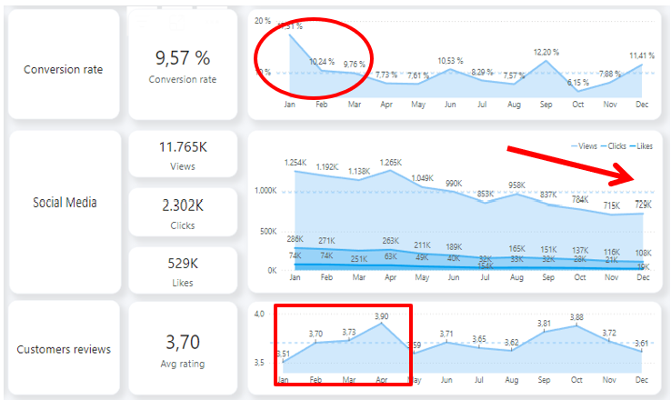

* **Decreased Conversion Rates:**
* The conversion rate demonstrated a strong rebound in December, reaching 10.2%, despite a notable dip to 5.0% in October.
* **Reduced Customer Engagement:**
  + There is a decline in overall social media engagement, with views dropping throughout the year.
  + While clicks and likes are low compared to views, the click-through rate stands at 15.37%, meaning that engaged users are still interacting effectively.
* **Customer Feedback Analysis:**
  + Customer ratings have remained consistent, averaging around 3.7 throughout the year.
  + Although stable, the average rating is below the target of 4.0, suggesting a need for focused improvements in customer satisfaction, for products below 3,5.

## Key Insights

### **Decreased** **Conversion** **Rates**

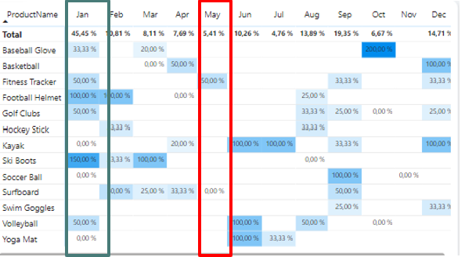

* **General Conversion Trend:**
  + Throughout the year, conversion rates varied, with higher numbers of products converting successfully in months like February and July. This suggests that while some products had strong seasonal peaks, there is potential to improve conversions in lower-performing months through targeted interventions.
* **Lowest Conversion Month:**
  + May experienced the lowest overall conversion rate at 5,4%, with no products standing out significantly in terms of conversion. This indicates a potential need to revisit marketing strategies or promotions during this period to boost performance.
* **Highest Conversion Rates:**

January recorded the highest overall conversion rate at 45.5%, driven significantly by the Ski Boots with a remarkable 150% conversion. This indicates a strong start to the year, likely fueled by seasonal demand and effective marketing strategies

### **Reduced Customer Engagement**

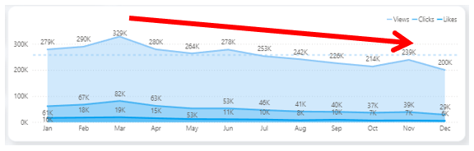

* **Declining Views:**
  + Views peaked in February and July but declined from August and on, indicating reduced audience engagement in the later half of the year.
* **Low Interaction Rates:**
  + Clicks and likes remained consistently low compared to views, suggesting the need for more engaging content or stronger calls to action.
* **Content Type Performance:**
  + Blog content drove the most views, especially in April and July, while social media and video content maintained steady but slightly lower engagement.

### **Customer Feedback Analysis**

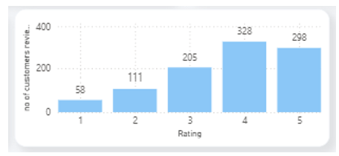 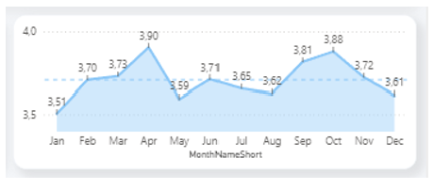

* **Customer Ratings Distribution:**
  + The majority of customer reviews are in the higher ratings, with 140 reviews at 4 stars and 135 reviews at 5 stars, indicating overall positive feedback. Lower ratings (1-2 stars) account for a smaller proportion, with 26 reviews at 1 star and 57 reviews at 2 stars.
* **Sentiment Analysis:**
  + Positive sentiment dominates with 275 reviews, reflecting a generally satisfied customer base. Negative sentiment is present in 82 reviews, with a smaller number of mixed and neutral sentiments, suggesting some areas for improvement but overall strong customer approval.
* **Opportunity for Improvement:**
  + The presence of mixed positive and mixed negative sentiments suggests that there are opportunities to convert those mixed experiences into more clearly positive ones, potentially boosting overall ratings. Addressing the specific concerns in mixed reviews could elevate customer satisfaction.

# Goals and Actions

## Increase conversion rates

### Goal

Identify factors impacting the conversion rate and provide recommendations to improve it.

### Insight

Highlight key stages where visitors drop off and suggest improvements to optimize the conversion funnel.

### Action

Target High-Performing Product Categories: Focus marketing efforts on products with demonstrated high conversion rates, such as Kayaks, Ski Boots, and Baseball Gloves. Implement seasonal promotions or personalized campaigns during peak months (e.g., January and September) to capitalize on these trends.

## Enhance Customer Engagement

### Goal

Determine which types of content drive the highest engagement

### Insight

Analyze interaction levels with different types of marketing content to inform better content strategies.

### Action

Revitalize Content Strategy: To turn around declining views and low interaction rates, experiment with more engaging content formats, such as interactive videos or user-generated content. Additionally, boost engagement by optimizing call-to-action placement in social media and blog content, particularly during historically lower-engagement months (September-December).

## Increase conversion rates

### Goal

Understand common themes in customer reviews and provide actionable insights

### Insight

Identify recurring positive and negative feedback to guide product and service improvements.

### Action

Address Mixed and Negative Feedback: Implement a feedback loop where mixed and negative reviews are analyzed to identify common issues. Develop improvement plans to address these concerns. Consider following up with dissatisfied customers to resolve issues and encourage re-rating, aiming to move average ratings closer to the 4.0 target.

# Dashboards Power BI

All dashboards can be filtered by year, months, or products.

## Overview

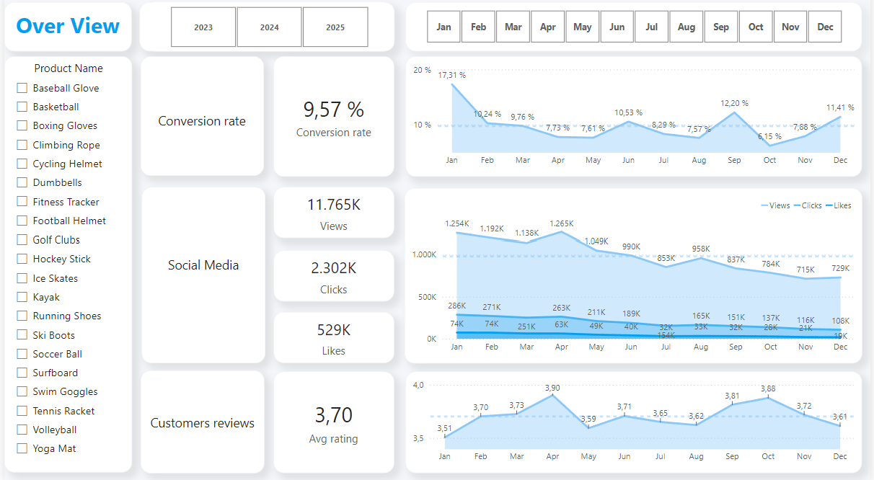

## Conversion rate

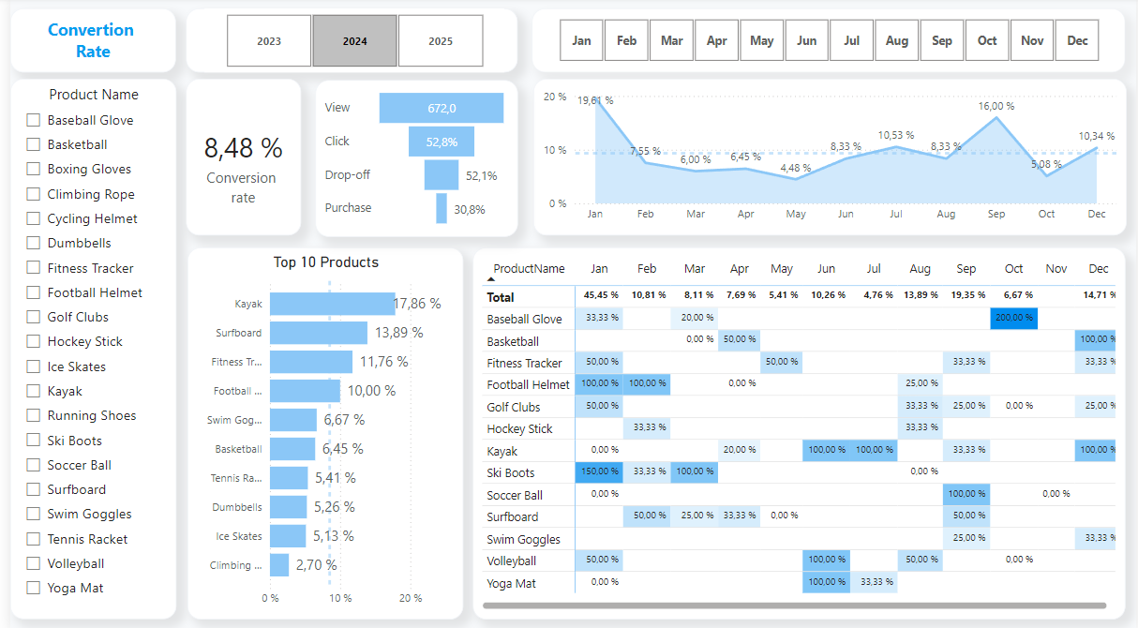

## Social media

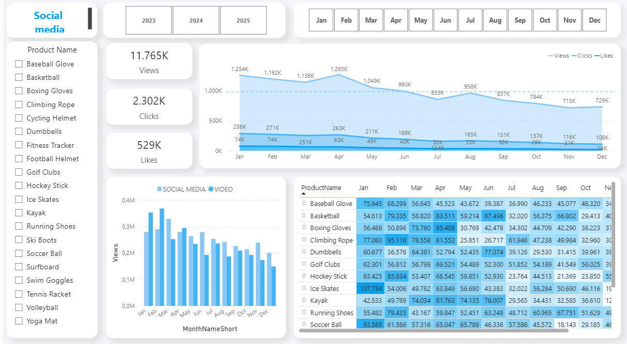

## Customer reviews

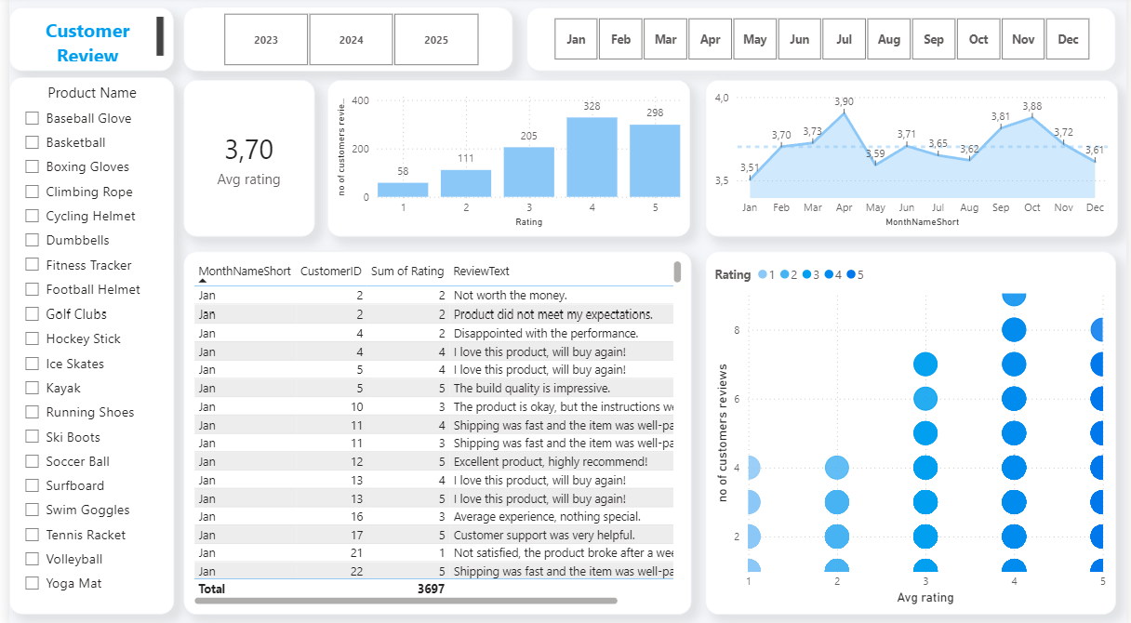

# SQL

## FACT tables

### Reviews

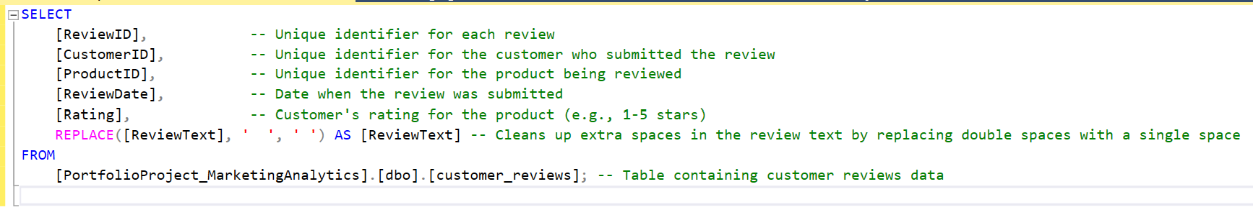

### Engagements

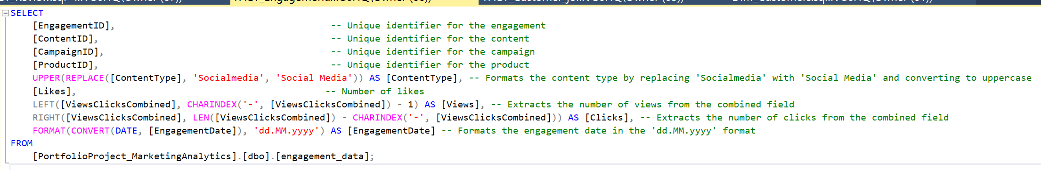

### Customer journey

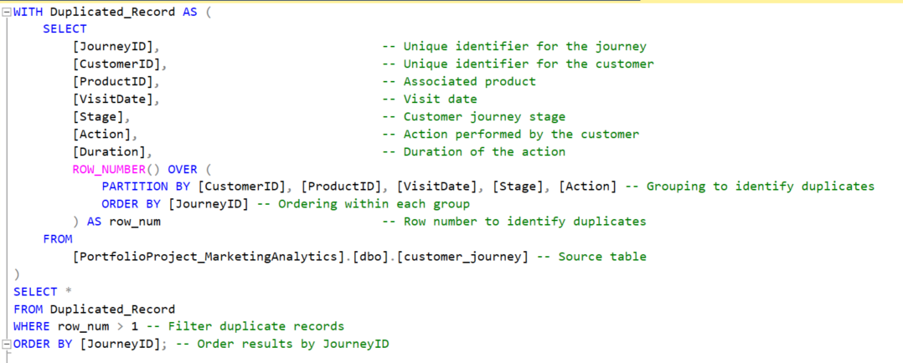

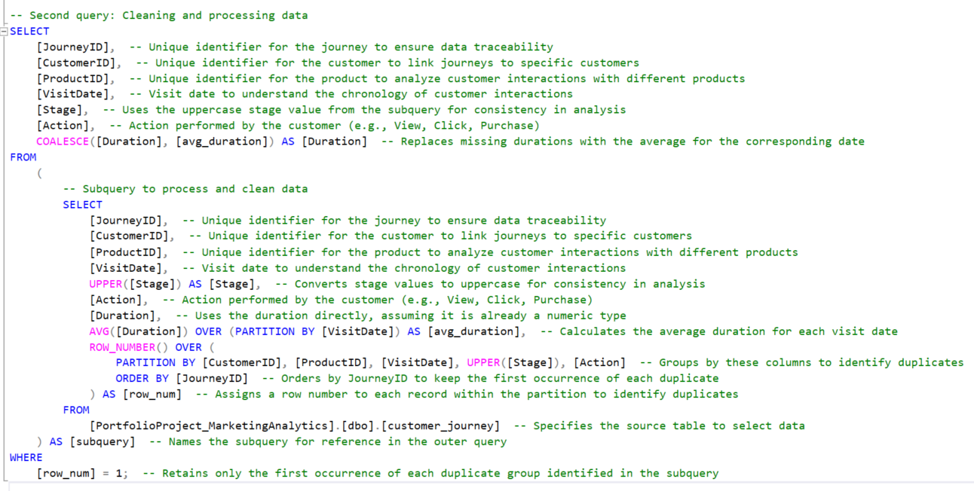

## Dimension tables

### Customers

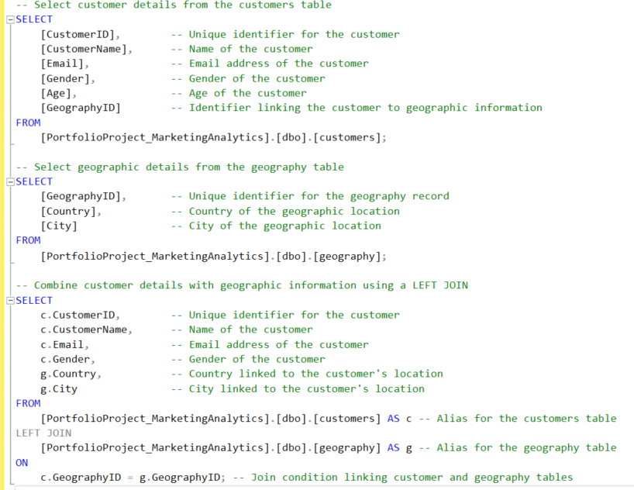

### Products

